015 TypeScript - for loop

TypeScript Kata List – Blog Page

[TypeScript Kata List on GitHub](https://github.com/robertdunaway/katas-typescript)

# Duration

5 minutes

# Brief

Using the “for” loop.

### For More Information

BING/GOOGLE: “TypeScript for loop”

# Instructions

Get tutorial folder or the entire katas-typescript repo.

Open the [before/*.sln] file and execute the kata.

Feel free to execute this kata multiple times because repetition creates motor memory.

# Github

* Before (start kata with this)
  + https://github.com/robertdunaway/katas-typescript/tree/master/015%20TypeScript%20-%20for%20loop/before
* After
  + https://github.com/robertdunaway/katas-typescript/tree/master/015%20TypeScript%20-%20for%20loop/after

# Kata

Create a for loop using an incremental index.

for (var index: number = 0; index < 10; index++) {

console.log(index);

}

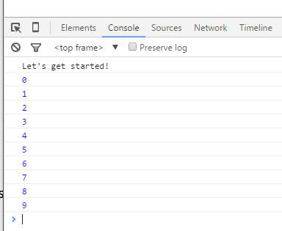

Imagine another for loop.

var myNumber: number = 5;

for (var multiplier = 1; multiplier <= 10; multiplier++) {

var result = myNumber * multiplier;

console.log(`${myNumber} * ${multiplier} = ${result}`);

}

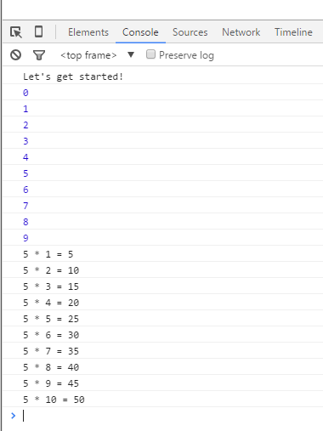

# Next

Take a few minutes and imagine more examples.